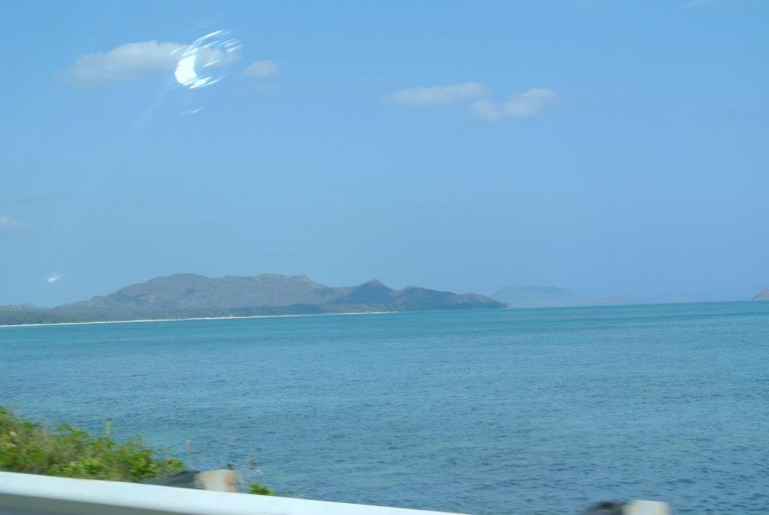
Fibromyalgia Healing
Retreat in Paradise
November 18-24, 2013

Lumeria Retreat Center
Maui’s Most Luxurious
Boutique Retreat
AVAILABLE:
- Consultations
with Dr. Metro by
appointment prior to
retreat
- Lomi Lomi Massage
- Massage Therapy
- Horticulture
- Aromatherapy
- Cranial Sacral Massage
- Personalized Yoga

INCLUDED:
- 3 Daily meals -
Local fruits, vegetables, fresh fish, vegan/vegetarian
- Yoga
- Meditation
- Jacuzzi
- Organic Gardens
- Evening Acoustic Yoga
- Pool

- Irene C. Metro M.D., Board Certified Physician and
Fibromyalgia /Chronic Fatigue Syndrome Specialist
Presents:
- Hawaiian Retreat for 7 Days and 6 Nights Oceanside

- Relax, commune with nature, enjoy workshops and pamper yourself.

- Give your health a boost and your fibromyalgia a boot

Call 734-432-1900 for more information
www.doctormetro.com

