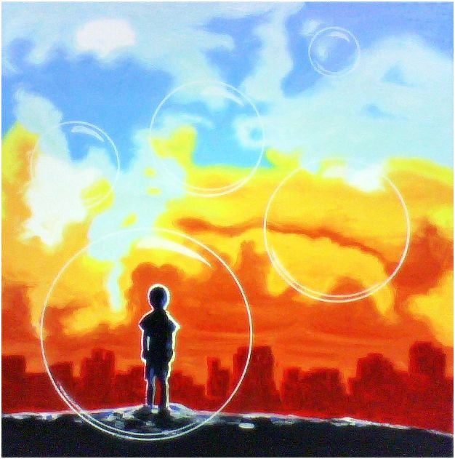

Dear Teacher,

I just wanted you to know;

I have special needs; there are things I do not understand. I look to you to help me figure out your world. I wish you would try to figure out my world too.

Today, when I was making that sound with my feet, I was reacting to sights and smells, lights, and noises all going on around me. Things you may never notice, but are very troublesome to me. After time, they make me feel anxious and nervous. I try to follow your rules of being still and quiet, but sometimes everything overwhelms me, and I am afraid I can’t hold it in. And then I am afraid you will be angry with me if I don’t, and that makes everything much worse.

At night when I go to sleep, my mind replays the things I have heard throughout my day; why can’t you be quiet, just get in line, keep your hands to yourself, leave that alone, what’s wrong with you? Then I wonder what IS wrong with me? Why can’t my teacher love me the way I am… like she does the normal kids? Why can’t I be normal? Does that mean I can only be loved if I am normal?

I wish you could see how hard it is for me to be who you want me to be. And when I get it right, even just once…I would be the happiest kid alive if you could celebrate that time with me. You see, I want to be just the kid you want me to be, honest! I want to be the one you smile at when I walk in the door. It is so very hard for me. Sometimes, I think I should just give up.

You don’t know this, but you will in one way or another be a part of my life for the rest of my life. Could you please think for a minute…do you want to be a positive experience that equips me for success? Or do you want to be the one that brings the sadness to my eyes whenever someone talks of school, and learning? You hold within your hands the power to bless my world or curse it. You tell me to make good choices. It’s your turn now. Will you choose wisely?

Yours truly,

Every special needs child you will ever teach

Hazel Greene

Hope Springs Advocates